Project Design Phase
Solution Architecture

Solution Architecture:
Solution architecture is a structured process that bridges the gap between realworld energy consumption challenges and advanced data analytics using Tableau. It ensures the design and delivery of a scalable and insightful solution tailored for analysing electricity usage patterns.
Its goals in the context of this project are to:
- Find the best tech solution to collect, process, and visualize electricity consumption data for better decision-making and resource optimization.
- Describe the structure, flow, and components of the Tableau-based
dashboard solution to stakeholders, including how data flows from sources to insights.
- Define the key features (such as peak consumption detection, time-based usage trends, location-wise patterns), the project’s development phases (data gathering, processing, visualization), and system requirements (storage,
processing, access control).
- Provide clear technical specifications for how the solution should be defined, developed, and deployed—ensuring performance, scalability, and usability.

How It's Applied in This Project:
- Business Problem: Inefficient energy use and lack of data-driven visibility in consumption patterns.
- Technology Solution: A Tableau-powered dashboard connected to
processed electricity data from smart meters, weather APIs, and utility records.

- Structure & Behavior: ETL pipelines feed cleaned and structured data into a central database, which Tableau uses to generate interactive and dynamic
visualizations.

Development Phases:
- Data Collection & Integration
- Data Cleaning & Transformation
- Dashboard Design in Tableau
- User Testing & Feedback
- Final Deployment & Training
  - Specifications: Includes data schema, visualization types, update frequency, access levels, and backup strategies.

Solution Architecture Diagram:
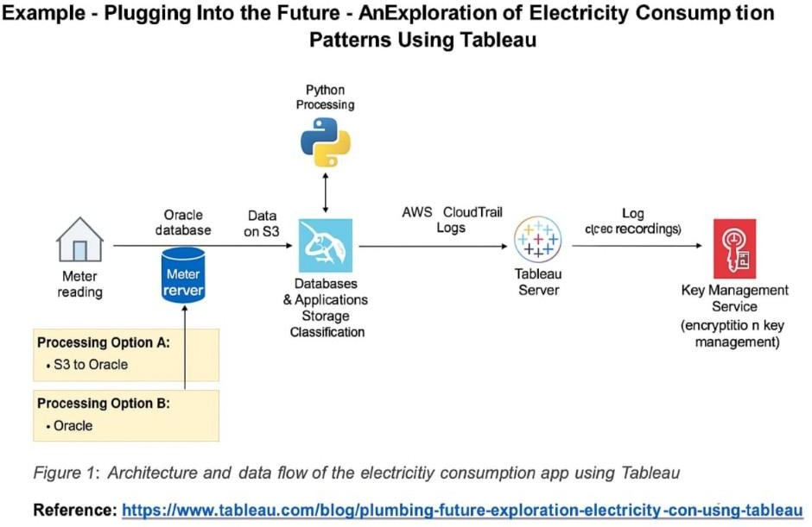
Reference:
https://www.tableau.com/blog/plugging-into-the-future- electricity-consumption-patterns-using-tableau

